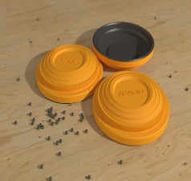

March 31: Week 1 Practice
April 7: Week 2 Practice
April 14: Week 3 Practice
April 14th – May 1st State Tournament registrations open
April 21: 1st competition
April 28: 2nd competition
May 5: 3rd competition
May 12: 4th competition
May 19th: 5th competition
Week of May 25th FUN WEEK
May 26th: Season Finals Posted
May 27th: National Registration opens up
June 1st – 30th state tournament
July 9th – 13th National Championships Mason, MI (Everyone can participate in Nationals if they attend all regular competitions and states tournaments)

If inclement weather during the normal competition day, alternate day will be available within the same week.

